1. **Create an EC2 instance with type t2.micro (in a public subnet)**

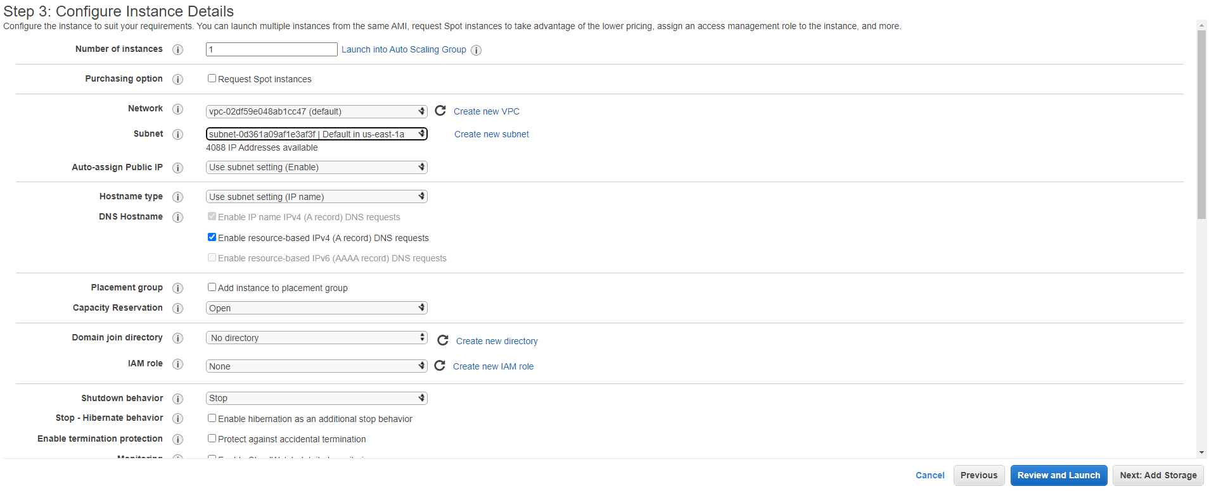



1. **Connect to the SSH instance**

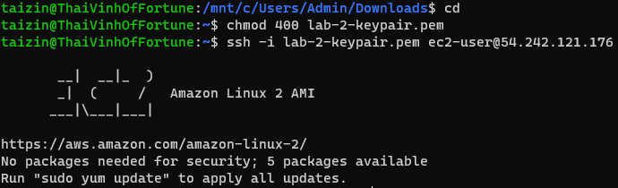

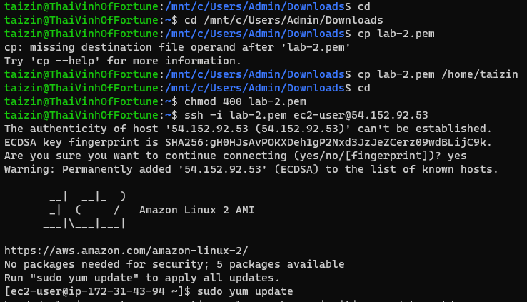

**Remove the authorized_keys and Disconnect the SSH**



